**VIRTUAL DOM**

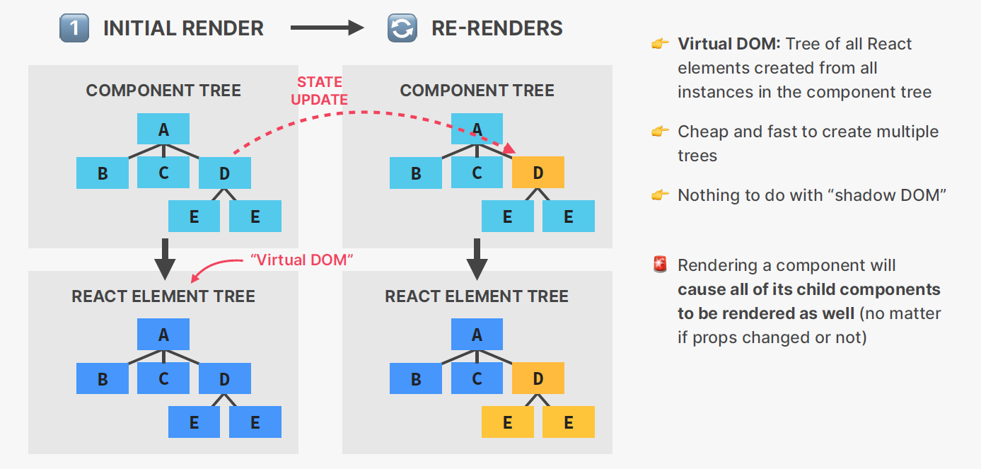

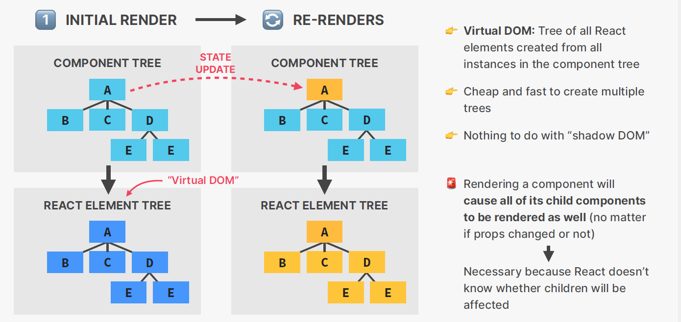

The virtual DOM is essentially a lightweight copy of the actual DOM. When changes are made to the state of the application, React uses the virtual DOM to determine the most efficient way to update the actual DOM. This process is known as reconciliation. By using the virtual DOM, React is able to minimize the amount of direct manipulation of the actual DOM, which improves the performance of the application.

One of the key benefits of the virtual DOM is its ability to selectively update only the components that have changed, rather than re-rendering the entire application. This is achieved through the use of a diffing algorithm, which compares the virtual DOM to the actual DOM and determines the minimal set of changes needed to bring them into alignment.

React's use of the virtual DOM results in a number of performance benefits. Firstly, since the virtual DOM is a lightweight copy of the actual DOM, it can be manipulated and updated much faster than the actual DOM. This means that React can quickly determine the minimal set of changes needed to update the UI, and apply those changes with minimal impact on performance.

Another benefit is that the virtual DOM allows React to batch updates, which means that instead of updating the actual DOM one component at a time, React can group multiple updates together and apply them all at once. This reduces the number of times the actual DOM needs to be updated, and thus further improves performance.

**Do you find it helpful?**

**Let me know down in the comments**



[](https://www.linkedin.com/in/anubhav-gupta-b68946132/)

**Click To Follow For More On LinkedIN**